World History

1. Some Concepts
   1. John Locke
      1. Wrote the book – *Two Treaties in Govt*
      2. Govt has the responsibility to give some rights to its people
         * Right to life, liberty, property
   2. Voltaire
      1. Called for separation of state with religion
      2. From this concept, the word secular came
   3. Rousseau
      1. Book/Theory – *The Social Contract*
      2. People and govt are bound in a contract (tax from people, govt will provide jobs/facilities)
   4. Montesquieu
      1. Book – *The Spirit of Laws*
         * Division of powers
2. American Revolution
   1. Around 1700
      1. East Coast of America – British
      2. Central America – French
      3. Southern America – Spain
   2. British clear French and Spanish out of America and make America its colony
   3. 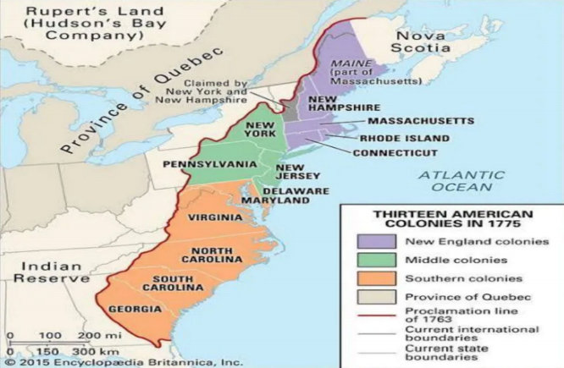Britain ruled only over the East Coast colonies of America (13), they did not rule over the current America as we know.
   4. British brought many bad laws which frustrated Americans:
      1. Writs of Assistance Act, 1761
         * General search warrant issued by superior provincial courts to assist the British government in enforcing trade and navigation laws.
         * Americans can be arrested without arrest warrant on basis of sedition.
      2. Sugar Act, 1764
         * Increased tax on sugar
      3. Navigation Act, 1651
         * Any product produced by 13 colonies can only be traded with Britain.
      4. Quartering Act, 1765
         * Required the colonies to provide barracks and supplies to British troops
      5. Stamp Act, 1765
         * Americans had to pay tax on printing paper with stamps (extra tax for stamp on paper) used for newspapers.
      6. Tea Act, 1773
         * British tea was not doing good business, forced Americans to not grow their own tea and buy only British tea.
         * Boston Tea Party, 1773 🡪 British send their tea by ship to Boston tea, angered crowd threw the chests of tea in sea.
         * British put sanctions on the Boston port, only British ships allowed.
   5. British removed Americans from the government in America
      1. People started the line – “No Tax without Representation”
         * This line was copied by Indian leaders during the freedom struggle.
   6. With people protesting against them, British attack Americans. Americans fight back!
      1. France supports Americans against their fight (money, soldiers, weapons)
   7. Declaration of Independence, 1776
      1. All men are created equal
      2. Right to life, liberty and pursuit of happiness.
      3. America to be made Republic.
   8. Lord Cornwallis vs George Washington – Cornwallis surrender (Siege of Yorktown, 1781)
   9. American Constitution (framed by Thomas Jefferson)
      1. Made Slavery legal
      2. Right to vote only if you have property
      3. Inequality in Constitution caused the American Civil War
   10. Charles A Beard – “*There is no change in America after independence*”
   11. American Civil War (1861-65)
       1. Federal states (Abraham Lincoln) vs Confederates (Southern States which supported slavery)
       2. The federal states in the north was not in favor of slavery and depended more on tech.
       3. 13th Amendment – ends slavery in America.
3. French Revolution